
Software Requirements Specification
for
Give2Get Project
Version 1.1

Prepared by
Group Number: 3

Beril Ege Tonyali | <student #> | egeberil@gmail.com
Orçun Güdücü | <student #> | guducuorcun@gmail.com
Renan Çakirerk | <student #> | renan.cakirerk@gmail.com
Durukan Duru | <student #> | mdduru@gmail.com
Mehmet Emrah Konya | <student #> | mehmetemrahk@gmail.com
Cem Emre Buruş | 2009719231 | cememreburus@gmail.com

Instructor: | Dr. Suzan Üsküdarlı
Course: | SWE 574 – Software Development As A Team
Date: | October 16th 2011
Contents

1 Introduction 1
2 Overall Description 3
3 Specific Requirements 5
4 Other Non-functional Requirements 10

Revisions
Version | Primary Author(s) | Description of Version | Date Completed
1.0 | Project Team | Initial document. | 10/10/2011
1.1 | Project Team | Updates based on new requirements. | 16/10/2011

Introduction

Document Purpose
Trading goods and services online, otherwise known as bartering, is becoming more popular in light of our troubled economy. It is not uncommon these days to see people trading one thing for another without the exchange of money.

This specification document presents the requirements of the Give2Get Project which aims the preparation of a website which makes it easy for people to trade goods and services without the exchange of money.

Product Scope
Give2Get is going to facilitate the trade of goods and services. One can trade anything for anything else, without the exchange of money. There are no fees to use the site. For instance, one can find handymen wanting to trade their services for tools; office furniture for a sewing machine; and books, cooking, and kids clothes for a new fence. The site will offer charitable exchanges where members can offer their services for charity.

Intended Audience and Document Overview
This document is intended for the client which is the professor of the course: SWE 574 – Software Development As A Team.

The rest of this SRS contains descriptions and specifications related with the project.

Definitions, Acronyms and Abbreviations
Below is a list of all abbreviations and acronyms used in this document sorted in alphabetical order.

IEEE: The Institute of Electrical and Electronics Engineers
SRS: Software Requirements Specification

Document Conventions
This document follows the IEEE formatting requirements:

- Arial font with size 11, or 12 is used throughout the document for text
- Comments are italicized.
- Text is single spaced and maintain the 1” margins.
- For Section and Subsection titles please follow the document.

References and Acknowledgments
“IEEE Software Requirements Specification Template”, www.cas.mcmaster.ca Oct.10,2011
“IEEE Citation Style Guide”,www.ijssst.info/info/IEEE-Citation-StyleGuide.pdf,Oct.10,2011
“How to Trade Goods and Services on the Web Without Money”, www.ehow.com,Oct.10,2011

Overall Description

Product Perspective
The product, Give2Get website, will be a new, self-contained system. It will neither be a part of a larger system nor a replacement for any existing system.

Product Functionality
- Give2Get website will be open to the Internet.
- Trade of any type of certain goods and services which are legally tradable in Turkey will be allowed.
- Service Provider and the Service Recipient will rate eachother by means of service quality after the service is provided. This is called the “rating process”.
- Evaluation will be measured with “rating”. Positive evaluation will increase the average rating balance and negative one will decrease it.
- Use of services will be free of charge but “points” will be used instead.
- Providing a service will be the way for earning points.
- Membership will require an invitation from a member.
- Misusing member will be penalized together with his/her inviter. Misusage and pentalies are described in Appendix I.
- Membership will be free of charge.
- Exchange of any type of monetary funds will not be allowed. Therefore, the system will not collect any type of financial data of the users and will not contain a payment system.

Users and Characteristics
Using the service of the Give2Get system requires membership. There is no limitation for becoming a member, everyone who accepts the disclaimer is allowed to become a member of the system.

Operating Environment
- Give2Get will be a web-based Java application.
- It will be designed to operate on Google Chrome 10, Firefox 6 web browser or on their higher editions.
- Windows 7, Mac OS X and Linux platforms will be supported.

Design and Implementation Constraints
- Programming language: Java
- Database: MySQL
- Control system: Git
- Application Server: Apache Tomcat
- Project Management: Google Project
- Language requirements: Website will only support English

User Documentation
A user manual document and online help with FAQ section will be prepared for user documentation. Both documents will be in HTML format.

Assumptions and Dependencies
The users of the system are assumed to have a personal computer with following operating and web browsing system specifications.

Operating System: Windows 7, Linux, Mac OS X Snow Leopard or above versions.
Web Browser: Firefox 4, and Google Chrome 11 or above versions.

Specific Requirements

External Interface Requirements

User Interfaces
Objects listed below will be the master page.

- Header
  - Logo
  - Search Box
  - Navigation menu
    - Sign in box
    - Sign up link
    - Menu items
- Footer
  - Link to “About” and “Disclaimer” pages

Main Page

Main page is the index page of the Give2Get web site.

The main page contains the following:
- Invite A Friend
- It shows a certain number of most recent services added.
- It shows top 5 rated users.
  - Username
  - Link to profile
  - Provider rating
  - May have the total amount of services that the user has added
- Top 5 viewed services

Service Details Page

- Service details page shows detailed information about a specific service.
- It has service information containing location, time, duration details.
- It has name, current rating and list of services of the owner of this service.
- It has a comment text box which enables the user to enter comments about this service.
- It has a rating bar which enables user to rate the service in 1 to 5 scale.

Registration Page

- Registeration page contains e-mail, username, password and security question information of the registering user.

User Profile Page
- Contains name, surname, phone number, education, photo and skills information from the registering user and his / her uploaded picture. There is also the recently provided services.

Edit User Information Page

- Edit user profile page contains all the same objects with user information page plus edit option for user information section objects.

Add Service Page
- Contains all the information of user taken during registration
- It has references of the user given by other user related with previous services.
- It has current credit and list of services of the owner of this service.

Edit Service Page
- This page contains the information of the selected service and allows users to make changes on the service information.
- The user can also delete a service from this page.

Functional Requirements

Function List
ACTORLERI ve Detaylari YAZ, use case body, ama o table'i cizmeyelim nolur. Gerek yok.

Invitation Function
- Invitation process takes e-mail information of an invitee from the inviter member.
- The e-mail provided is recorded to the database.
- The intiviation number of the inviter will be decreased by one.

Registration Function
- Registration process takes e-mail, username and password information from newly registering user and creates a member record in the database with a unique member number.
- E-mail and user name information are checked with previous records since neither of them can be used twice.
- Password must be at least 6 alphanumeric characters long and verified by double entry.
- E-mail address and registration must be verified with a verification e-mail sent to the e-mail address specified. E-mail contains the unique verification link.
- Before the registration is verified, it is first recorded into the database with pending status. After verification the status is turned to permanent status.

View Profile Function
- This function allows the user to view the details of the user.

Edit Profile Function
- All of the user information is editable any time after the registration.

Add Service Function
- Add service function takes location, time, period details from the identifier.

Edit Service Function
- All of the service information is editable any time after the service is registered.
- It receives comment and rating information from the recipient user and records this information to the database.

Rate Service Function
- Rating function takes the rating information from both the provider and the receiver; then records it to the database.
- Rating as a provider and rating as a recipient will be calculated separately for each member.

List Top Rated Users Function
- Top 5 users with highest average rating records are listed in the main page.
- The top rated user must provide at least 5 rated services.

List Top Visited Function

List Recently Added Services Function
This function lists the last 10 recently added services.

Comment Service Function

View Service Function

Delete Service Function

Confirm Service Request Function

Apply to Service Function

Quick Search Function
- Search function searches the entered string in database. Service message body and tags fields will be investigated.

Detailed Search Function

Rate Function

Point Function
- When the status of an invitation turns to completed, the rate function adds extra credit to the provider balance of the inviter.
- When a service is used by a recipient and it is status is set to the completed both by the provider and the receiver; the provider earns and the receiver loses the same amount of points.
- Top 5 service providers with highest total credit records are listed in the main page.

Use Cases

Invite
Use Case No | UC01
Use Case Name | Invite
Defined By | Durukan Duru |  | Last Updated By | Durukan Duru
Defined On | 2011/10/17 |  | Last Updated On | 2011/10/17
Actors: | Registered User
Descriptions | User shall be able to invite their friends using invitation form.
Pre-conditions | User shall be logged in to the system. E-mail for the invitee shall not be registered before.
Post-conditions | System shall send invitation to the intended invitee and record their data to database.
Priority | Low
Frequency of Use | Less frequent
Basic Flow | - User inserts intended invitee’s firstname, lastname, and e-mail address to related form fields  - User hits Send button.
Alternative Flows | - User cancels operation.
Exceptions | N/A
Referenced Use Cases | N/A
Special Requirements | N/A
Assumptions | N/A
Notes: | N/A

Register
Use Case No | UC02
Use Case Name | Register
Defined By | Durukan Duru |  | Last Updated By | Durukan Duru
Defined On | 2011/10/17 |  | Last Updated On | 2011/10/17
Actors: | Unregistered User
Descriptions | Unregistered user shall sign up to the system using registration form.
Pre-conditions | User e-mail and selected user name shall not be registered to the system.
Post-conditions | System shall record the user to the database. System shall generate a verification code and send it to the user.
Priority | Very high
Frequency of Use | Very frequent
Basic Flow | - User inserts firstname, lastname, e-mail address, user name, and password to related form fields.  - User hits Register button.
Alternative Flows | - User cancels operation.
Exceptions | N/A
Referenced Use Cases | N/A
Special Requirements | User password shall be at least 6 alphanumeric characters long.
Assumptions | N/A
Notes: | N/A

Browse Profile
Use Case No | UC03
Use Case Name | Browse Profile
Defined By | Durukan Duru |  | Last Updated By | Durukan Duru
Defined On | 2011/10/17 |  | Last Updated On | 2011/10/17
Actors: | Registered User
Descriptions | Registered user shall display profile page for any user.
Pre-conditions | User shall be logged in to the system.
Post-conditions | N/A
Priority | High
Frequency of Use | Frequent
Basic Flow | - User shall hit any user name.  - Profile page with user information for intended user displays.
Alternative Flows | - User may hit Profile link on any page to go to their own profile.  - On their own profile page, users shall be provided with an Edit button.
Exceptions | N/A
Referenced Use Cases | N/A
Special Requirements | User password shall be at least 6 alphanumeric characters long.
Assumptions | N/A
Notes: | N/A

Behaviour Requirements

Use Case View

The Service Provider

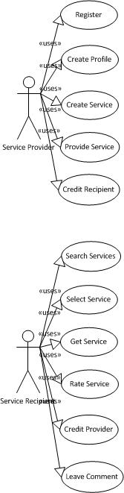
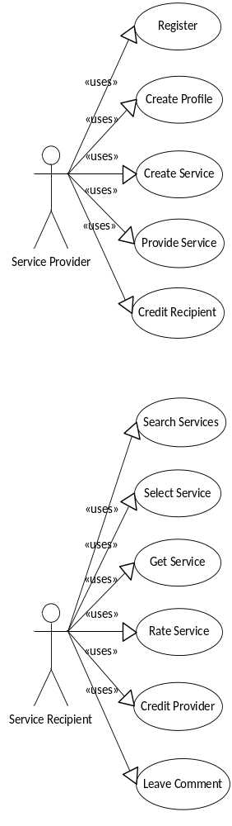

The Service Recipient

Other Non-functional Requirements

Safety and Security Requirements
- All client-server operations through the Internet will be through SSL to provide security

